**CHAPTER - 1**

**COMPANY PROFILE**

**Introduction:**

INFOWIZ is leading strategic IT Company offering integrated IT solution. INFOWIZ is having rich experience managing global clients across various business verticals and align IT strategies to achieve business goals. The various accreditations that we achieved for every service, we offer reflect our commitment towards the quality assurance.

INFOWIZ is a 7 years young organization with an ISO Certification & a member of Confederation of Indian Industry (CII membership number – N4654P) . We also provide the off shore companies of US, UK, France, Ireland, Canada and Australia with quality and timely Web and SEO services.

INFOWIZ is an organization which is established in the field of Web Development (PHP & .NET), JAVA (Core as well as Advance), I-phone & Android Applications, Embedded systems (AVR, PIC & ARM), ROBOTICS and Networking (MCSE, CCNA & RHSE), Mechanical Engineering (CRDi, CATIA, VVT, VCR, ABS, CRUISE CONTROL, PRO-E, SOLID WORKS).

Our skilled team of professionals make sure that the product is developed as per the customer’s needs and keeping the customer informed about the development of their project from time to time. We do not only emphasize on formulating an attractive solution to our clients but also believe in providing a workable solution. INFOWIZ offers research based Search Engine Marketing products that help achieve greater insights to customer’s online business. Our Research & Development arm offers SEO tools for SEM professionals.

INFOWIZ also provides Technical Support & Consultancy to Software Companies like JIA Group, New Zealand, Sagitech solutions Panchkula, Jarcinfotech Mohali, Infonet SolutionDelhi, web it solutions, Speedinforays etc.

**Our Hottest Clients & Projects:**

**PROJECTS URL’s COUNTRY**

1.) Viva Sales www.[infowiz.in/vivasales](http://infowiz.in/vivasales) UK

2.) Mds Creative [www.mdscreative.com](http://www.mdscreative.com) Germany

3.) Liddle TV www.filmon.com UK

4.) Paradigms(Android) running Australia

5.) Printcost [www.popgraphics.net](http://www.popgraphics.net) UK

6.) PSTDO Bootstrap [www.bootstrap.achiever.com](http://www.bootstrap.achiever.com) USA

7.) Essencesoftwares [www.essencesoftwares.com](http://www.essencesoftwares.com) Australia

8.) Dashboard(Wordpress) running USA

9.) Realstate [www.realestate.infowiz.in](http://www.realestate.infowiz.in) Russia

10.) Dealpartners(WordPress) [www.dealpartners.co.uk](http://www.dealpartners.co.uk) UK

11.) Littletonvineyard www.littletonvineyard.net USA

**Courses Offered :**

**For CSE/IT/MCA Professionals:**

1. Web Development in PHP with LIVE Projects
2. Web Development in .NET with LIVE Projects
3. Full Stack Development in Django/MERN/MEAN
4. JAVA (Core as well as Advance ) with LIVE Projects
5. Android Applications with LIVE Projects
6. Web Designing (Photoshop, Coral Draw)
7. C#, Console Applications, VB.NET, ASP.NET
8. MySQL, SQL, ORACLE
9. Networking (MCSE, CCNA, RHSE)
10. SEO (Search Engine Optimization)

**For ECE/EE/EIE Professionals:**

1. Robotics With Live Project
2. VLSI-VHDL with Live Project
3. Embedded System Design with Live Project
4. Microcontroller with Live Project
5. Microprocessor with Live Project
6. PCB Designing
7. AVR & PIC Family
8. PCB and layout designing
9. AUTOMATION with Live Project

10.) Project development with ARM processors

**For ME/ECE Professionals:-**

1. CRDi Technology
2. ABS, CRUISE CONTROL
3. MPFi&EFi Technology
4. CATIA
5. PRO-E
6. AUTOCAD/CAM
7. SOLIDWORKS

Our core strength is our timely, technically and cost effective project delivery. We also provide customers with designs as per their demands. INFOWIZ also provide Industrial Training of 6 Months & 6 Weeks in ME / IT & Electronics to B.Tech, MCA students. We help students in building their career.

**CHAPTER - 2**

**INTRODUCTION TO PROJECT**

**Blood Connect:** This project is aimed to develop an online Blood Information. In this Project we can collect an information about the donor, receiver and camp that are related to donating, receiving the blood. Through this website any person who is interested in donating the blood can register himself and in the same way if any user want to add a camp can insert it. Moreover if any general consumer wants to make request blood online he can also take the help of this site. Admin is the main authority who can do addition, deletion, and modification if required.

The various pages having details such as:

1. Donor and receiver registration
2. Insert new camp
3. View total blood and received blood
4. Insert blood
5. Insert blood bank
6. Manage blood bank
7. Insert camp
8. Manage camp

**CHAPTER - 3**

**MODULES OF PROJECT**

This project has been divided into 3 main modules. The User, Admin and Bank Manager.

**1. User**

The new user can register itself to site by filling the registration form. The user can register as a donor if he wants to donate blood. If user want to receive want he can register as a receiver also. By registering as receiver the user can take the needed blood from the bank where it is available. If any user want to organise any camp he can insert a new camp.

**2. Admin**

Admin manage all the data of users. Admin can view the registered users, view donors, view receivers. Admin also insert and manage the blood bank. In mange bank admin can delete any bank or can update it. Blood can also get inserted through manage bank. All the blood details can also be viewed.

Admin can also insert and manage camp. A new can be inserted and old one can be deleted. Admin can also view the feedback.

**3. Bank Manager**

By login with bank **userid** bank manager can view blood which is available in that particular bank. Bank manager can also insert the blood in his bank. In this he can also view the blood which is received by any person from this particular bank.

If any person has donated the blood the bank manager will add the blood to this bank. So that anyone who need it will receive from this bank.

**CHAPTER - 4**

**TECHNOLOGIES USED**

**FRONT END**

**4.1 HTML/CSS/JS/Bootstrap**

**HTML (Hyper Text Markup Language)** documents are written in plain text (ASCII) with special markup codes embedded right in the text. This means HTML files contain nothing but printable characters and HTML markup codes. This is unlike a Word file which can contain special characters for formatting functions. What distinguishes an HTML file from any other plain - text file is the presence of markup codes. Markup codes are typed into a document and control the formatting and layout of your finished document. The markup codes that are typed into a document are enclosed within these angle brackets: "< >". The angle brackets and the markup codes together constitute a tag. When you are talking about an HTML document you refer to it as a "source" document. Here is an example of the "source" of a simple HTML document: <HTML> <HEAD> <TITLE>Simple HTML document</TITLE> </HEAD> <BODY> this is a very simple html document. </BODY> </HTML.

**CSS(Cascading Stylesheet)** It is the language for describing the presentation of Web pages, including colors, layout, and fonts, thus making our web pages presentable to the users. CSS is designed to make style sheets for the web. It is independent of HTML and can be used with any XML-based markup language.

* Cascading: Falling of Styles
* Style: Adding designs/Styling our HTML tags
* Sheets: Writing our style in different documents
* Selector: selects the element you want to target
* Always remains the same whether we apply internal or external styling
* There are few basic selectors like tags, id’s, and classes
* All forms this key-value pair
* Keys: properties (attributes) like color, font-size, background, width, height, etc.
* Value: values associated with these properties

**Bootstrap**

Bootstrap is a [free, open source](https://www.techtarget.com/whatis/definition/Free-and-open-source-software-FOSS-or-free-libre-open-source-software-FLOSS) [front-end](https://www.techtarget.com/whatis/definition/front-end) development framework for the creation of websites and web apps. Designed to enable [responsive](https://www.techtarget.com/whatis/definition/responsive-design) development of [mobile-first](https://www.techtarget.com/searchmobilecomputing/definition/mobile-first) websites, Bootstrap provides a collection of syntax for template designs.

As a framework, Bootstrap includes the basics for responsive web development, so developers only need to insert the code into a pre-defined grid system. The [Bootstrap framework](https://www.theserverside.com/quiz/12-tough-Bootstrap-5-quiz-questions-for-web-developers) is built on Hypertext Markup Language ([HTML](https://www.theserverside.com/definition/HTML-Hypertext-Markup-Language)), cascading style sheets ([CSS](https://www.theserverside.com/definition/cascading-style-sheet-CSS)) and [JavaScript](https://www.theserverside.com/definition/JavaScript). Web developers using Bootstrap can build websites much faster without spending time worrying about basic commands and functions.

Bootstrap makes responsive web design a reality. It makes it possible for a web page or app to detect the visitor's screen size and orientation and automatically adapt the display accordingly. The mobile-first approach assumes [smartphones](https://www.techtarget.com/searchmobilecomputing/definition/smartphone), [tablets](https://www.techtarget.com/searchmobilecomputing/definition/tablet-PC) and task-specific mobile apps are employees' primary tools for getting work done. Bootstrap addresses the requirements of those technologies in design and includes [UI](https://www.techtarget.com/searchapparchitecture/definition/user-interface-UI) components, layouts, JavaScript tools and the implementation framework. The software is available precompiled or as [source code](https://www.techtarget.com/searchapparchitecture/definition/source-code).

**Javascript** JavaScript is a dynamic programming language that's used for web development, in web applications, for game development, and lots more. It allows you to implement dynamic features on web pages that cannot be done with only HTML and CSS. HTML defines the structure of your web document and the content therein. CSS declares various styles for the contents provided on the web document.

HTML and CSS are often called markup languages rather than programming languages, because they, at their core, provide markups for documents with very little dynamism.

JavaScript, on the other hand, is a dynamic programming language that supports Math calculations, allows you to dynamically add HTML contents to the [DOM](https://thewebfor5.com/p/javascript/the-dom/), creates dynamic style declarations, fetch contents from another website, and lots more.

Before we go into how JavaScript does all of these things, let's look at a quick example.

**4.2 Introduction to Django:**

The Django web framework is a free, open source framework that can speed up development of a web application being built in the Python programming language. Django facilitates “rapid development and clean, pragmatic design.” The Django web framework, deployed on a web server, can help developers quickly produce a web frontend that’s feature-rich, secure and scalable.

Starting with the Django web framework is more efficient way to build a web app than starting from scratch, which requires building the backend, APIs, javascript and sitemaps. With the Django web framework, web developers can focus on creating a unique application and benefit from greater flexibility than using a web development tool.

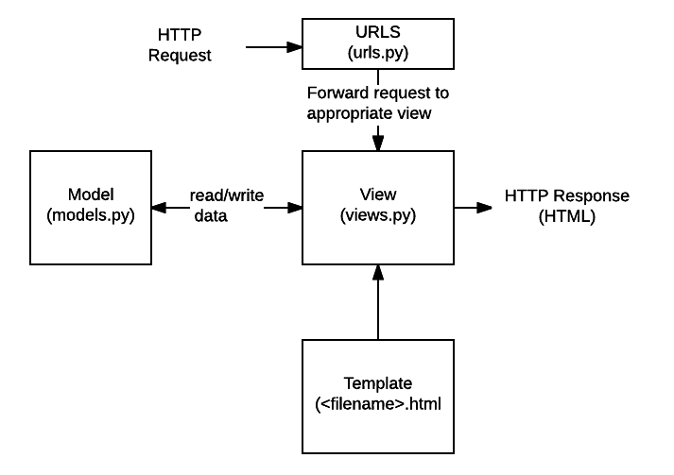

**4.5 SQLite:**

SQLite is an in-process library that implements a self-contained, serverless, zero-configuration, transactional SQL database engine. It is a database, which is zero-configured, which means like other databases you do not need to configure it in your system.

SQLite engine is not a standalone process like other databases, you can link it statically or dynamically as per your requirement with your application. SQLite accesses its storage files directly.

## **Why SQLite?**

* SQLite does not require a separate server process or system to operate (serverless).
* SQLite comes with zero-configuration, which means no setup or administration needed.
* A complete SQLite database is stored in a single cross-platform disk file.
* SQLite is very small and light weight, less than 400KiB fully configured or less than 250KiB with optional features omitted.
* SQLite is self-contained, which means no external dependencies.
* SQLite transactions are fully ACID-compliant, allowing safe access from multiple processes or threads.
* SQLite supports most of the query language features found in SQL92 (SQL2) standard.
* SQLite is written in ANSI-C and provides simple and easy-to-use API.
* SQLite is available on UNIX (Linux, Mac OS-X, Android, iOS) and Windows (Win32, WinCE, WinRT).

**CHAPTER – 5**

**DATA FLOW DIAGRAMS**

**Login Process:**

**Read User Id and password**

**Is User Id and Password correct**?

**No**

**Successfully Logged In**

**Yes**

**Registration Process:**

**Check Required Blood**

**Enquiry**

**If Blood Exist?**

**Yes**

**Registration**

**No**

**DFD Level 0**

**Admin:**

Insert Bank,

Insert Camp and View Details

Admin

**User:**

Insert Camp, Receive Blood and Donate Blood

User

**Bank:**

Bank

Insert Blood, View Receivers, View Blood

**DFD Level 1**

**Admin:**

Admin

Database

**User:**

User

**Bank:**

Bank

Database

**DFD Level 2**

**Admin**

Username Password

Database Database

Admin

Database

Blood Database Camp Database

**User:**

username password

User

Donor Receiver

Database Database

Camp Database

**Bank:**

username password

Bank Manager

Receiver

Database Database

Bank Database

**CHAPTER – 6**

**DATABASE TABLES**

**New User:**

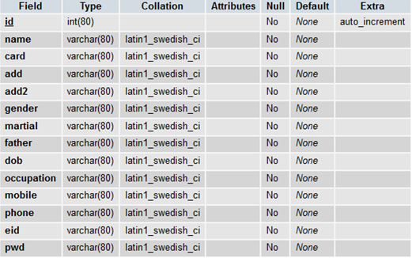

**Camp:**

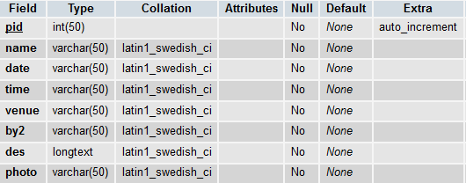

**Bank:**

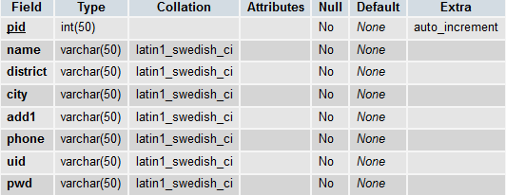

**Total Blood:**

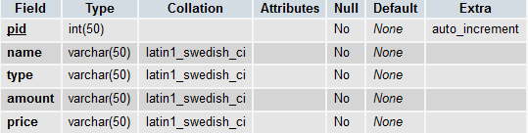

**Blood Request:**

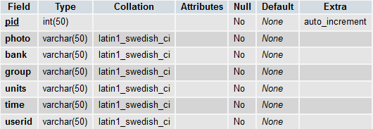

**Receiver:**

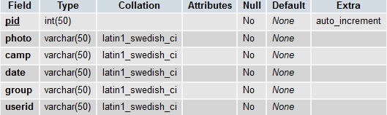

**Feedback:**

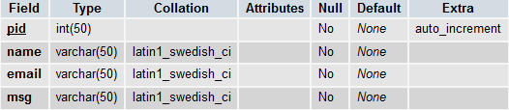

**LIST OF FIGURES**

**Fig. 1 Home Page of the website**

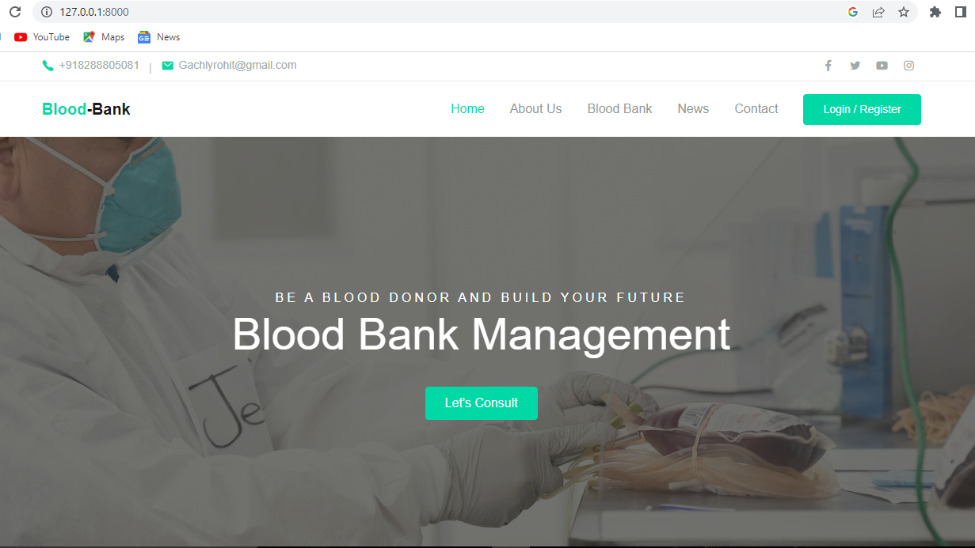

**Fig. 2 News**

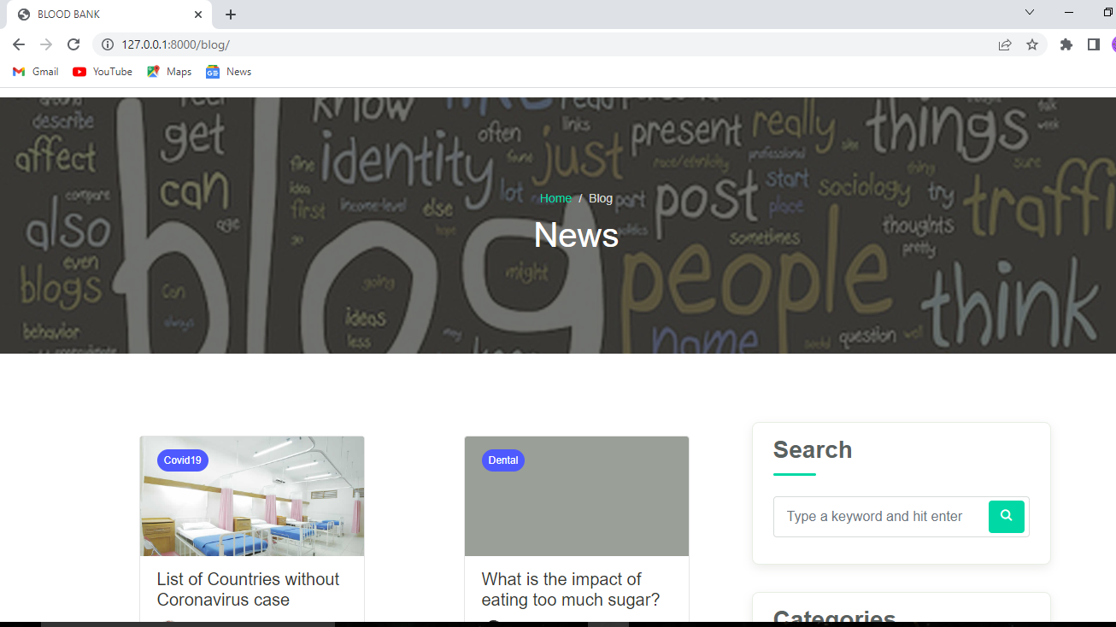

**Fig. 3 Contact Us**

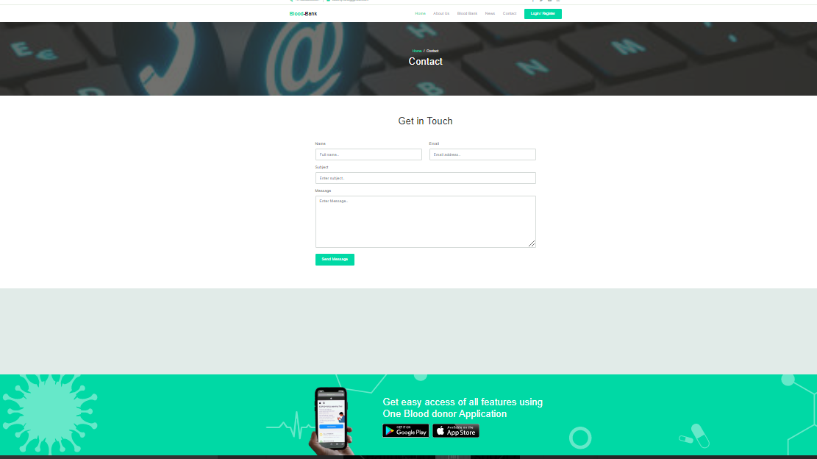

**Fig. 5 Login/ Register Form**

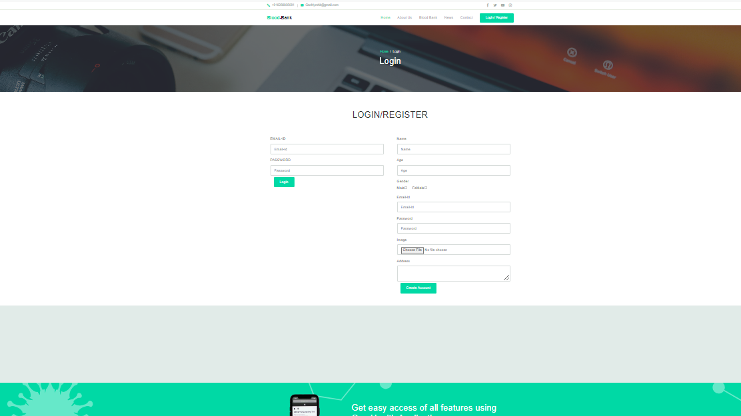

**References**

1. <http://www.wikipedia.com>

2. <http://www.answer.com>

3. <http://www.microsoft.com>

4. <http://www.codeproject.com>

**Project Code:**

{% load static %}

{% include 'template/topmenu.html' %}

  <div class="page-banner overlay-dark bg-image" style="background-image: url({% static 'assets/img/ry.jpg' %});">

    <div class="banner-section">

      <div class="container text-center wow fadeInUp">

        <nav aria-label="Breadcrumb">

          <ol class="breadcrumb breadcrumb-dark bg-transparent justify-content-center py-0 mb-2">

            <li class="breadcrumb-item"><a href="index.html">Home</a></li>

            <li class="breadcrumb-item active" aria-current="page">About</li>

          </ol>

        </nav>

        <h1 class="font-weight-normal">About Us</h1>

      </div> <!-- .container -->

    </div> <!-- .banner-section -->

  </div> <!-- .page-banner -->

  <div class="page-section bg-light">

    <div class="container">

      <div class="row">

        <div class="col-md-4 py-3 wow zoomIn">

          <div class="card-service">

            <div class="circle-shape bg-secondary text-white">

              <span class="mai-chatbubbles-outline"></span>

            </div>

            <p><span>Chat</span> with a doctors</p>

          </div>

        </div>

        <div class="col-md-4 py-3 wow zoomIn">

          <div class="card-service">

            <div class="circle-shape bg-primary text-white">

              <span class="mai-shield-checkmark"></span>

            </div>

            <p><span>One</span>-Health Protection</p>

          </div>

        </div>

        <div class="col-md-4 py-3 wow zoomIn">

          <div class="card-service">

            <div class="circle-shape bg-accent text-white">

              <span class="mai-basket"></span>

            </div>

            <p><span>One</span>-Health Pharmacy</p>

          </div>

        </div>

      </div>

    </div>

  </div>

  <div class="page-section">

    <div class="container">

      <div class="row justify-content-center">

        <div class="col-lg-8 wow fadeInUp">

          <h1 class="text-center mb-3">Welcome to our Blood Bank Center</h1>

          <div class="text-lg">

            <p>Blood banking is the process that takes place in the lab to make sure that donated blood, or blood products, are safe before they are used in blood transfusions and other medical procedures. Blood banking includes typing the blood for transfusion and testing for infectious diseases.</p>

            <p>Expedita iusto sunt beatae esse id nihil voluptates magni, excepturi distinctio impedit illo, incidunt iure facilis atque, inventore reprehenderit quidem aliquid recusandae. Lorem ipsum dolor sit amet consectetur adipisicing elit. Laudantium quod ad sequi atque accusamus deleniti placeat dignissimos illum nulla voluptatibus vel optio, molestiae dolore velit iste maxime, nobis odio molestias!</p>

          </div>

        </div>

        <div class="col-lg-10 mt-5">

          <h1 class="text-center mb-5 wow fadeInUp">Our Doctors</h1>

          <div class="row justify-content-center">

            <div class="col-md-6 col-lg-4 wow zoomIn">

              <div class="card-doctor">

                <div class="header">

                  <img src="{% static 'assets/img/doc8.png' %}" alt="">

                  <div class="meta">

                    <a href="#"><span class="mai-call"></span></a>

                    <a href="#"><span class="mai-logo-whatsapp"></span></a>

                  </div>

                </div>

                <div class="body">

                  <p class="text-xl mb-0">Dr.natasha</p>

                  <span class="text-sm text-grey">Cardiology</span>

                </div>

              </div>

            </div>

            <div class="col-md-6 col-lg-4 wow zoomIn">

              <div class="card-doctor">

                <div class="header">

                  <img src="{% static 'assets/img/doc7.png' %}" alt="">

                  <div class="meta">

                    <a href="#"><span class="mai-call"></span></a>

                    <a href="#"><span class="mai-logo-whatsapp"></span></a>

                  </div>

                </div>

                <div class="body">

                  <p class="text-xl mb-0">Dr.alexa</p>

                  <span class="text-sm text-grey">Dental</span>

                </div>

              </div>

            </div>

            <div class="col-md-6 col-lg-4 wow zoomIn">

              <div class="card-doctor">

                <div class="header">

                  <img src="{% static 'assets/img/doc6.png' %}" alt="">

                  <div class="meta">

                    <a href="#"><span class="mai-call"></span></a>

                    <a href="#"><span class="mai-logo-whatsapp"></span></a>

                  </div>

                </div>

                <div class="body">

                  <p class="text-xl mb-0">Dr.john</p>

                  <span class="text-sm text-grey">General Health</span>

                </div>

              </div>

            </div>

          </div>

        </div>

      </div>

    </div>

  </div>

  <div class="page-section banner-home bg-image" style="background-image: url(../assets/img/banner-pattern.svg);">

    <div class="container py-5 py-lg-0">

      <div class="row align-items-center">

        <div class="col-lg-4 wow zoomIn">

          <div class="img-banner d-none d-lg-block">

            <img src="{% static 'assets/img/mobile_app.png' %}" alt="">

          </div>

        </div>

        <div class="col-lg-8 wow fadeInRight">

          <h1 class="font-weight-normal mb-3">Get easy access of all features using One blood donation application</h1>

          <a href="#"><img src="../assets/img/google_play.svg" alt=""></a>

          <a href="#" class="ml-2"><img src="{% static 'assets/img/app_store.svg' %}" alt=""></a>

        </div>

      </div>

    </div>

  </div> <!-- .banner-home -->

  {% include 'template/footer.html' %}

**Admin page**

{% load static %}

{% include 'template/adminmenu.html' %}

<div class="page-hero bg-image overlay-dark" style="background-image: url({% static 'assets/img/g9.jpg' %});">

    <div class="hero-section">

      <div class="container text-center wow zoomIn">

        <span class="subhead">Live a Longer Life with Blood Donation</span>

        <h1 class="display-4">Blood Bank </h1>

        <a href="#" class="btn btn-primary">Let's Consult</a>

      </div>

    </div>

  </div>

  <div class="bg-light">

    <div class="page-section py-3 mt-md-n5 custom-index">

      <div class="container">

        <div class="row justify-content-center">

          <div class="col-md-4 py-3 py-md-0">

            <div class="card-service wow fadeInUp">

              <div class="circle-shape bg-secondary text-white">

                <span class="mai-chatbubbles-outline"></span>

              </div>

              <p><span>Chat</span> with a doctors</p>

            </div>

          </div>

          <div class="col-md-4 py-3 py-md-0">

            <div class="card-service wow fadeInUp">

              <div class="circle-shape bg-primary text-white">

                <span class="mai-shield-checkmark"></span>

              </div>

              <p><span>One</span>-Health Protection</p>

            </div>

          </div>

          <div class="col-md-4 py-3 py-md-0">

            <div class="card-service wow fadeInUp">

              <div class="circle-shape bg-accent text-white">

                <span class="mai-basket"></span>

              </div>

              <p><span>One</span>-Health Pharmacy</p>

            </div>

          </div>

        </div>

      </div>

    </div> <!-- .page-section -->

    <div class="page-section pb-0">

      <div class="container">

        <div class="row align-items-center">

          <div class="col-lg-6 py-3 wow fadeInUp">

            <h1>Welcome to Blood Bank<br> Center</h1>

            <p class="text-grey mb-4">Blood Transfusion Service is a vital part of the National Health Service and there is no substitute for Human Blood and its components. Increasing advancement in the field of Transfusion Technology has necessitated to enforce stricter control over the quality of Blood and its products. In most of the developed countries, the blood banking system has advanced in all facets of donor management, storage of blood, grouping and cross matching, testing of transmissible diseases, rationale use of blood and distribution. The Govt. has the full responsibility for the blood programme even though, in some countries, the management of blood transfusion services are delegated fully or partly to an appropriate non-governmental organization (NGOs) working on a non-profit basis, e.g. Red Cross Society. When a NGO is assigned this responsibility, the Govt. should formally recognize it and give a clear mandate formulating the national blood policy, it is important to consider policy decisions enforcing appropriate regulations or necessary functions of health service to ensure high quality service and safe blood.

            </p>

            <a href="about.html" class="btn btn-primary">Learn More</a>

          </div>

          <div class="col-lg-6 wow fadeInRight" data-wow-delay="400ms">

            <div class="img-place custom-img-1">

              <img src="{% static 'assets/img/bg-doctor.png' %}" alt="">

            </div>

          </div>

        </div>

      </div>

    </div> <!-- .bg-light -->

  </div> <!-- .bg-light -->

  <div class="page-section">

    <div class="container">

      <h1 class="text-center mb-5 wow fadeInUp">Our Doctors</h1>

      <div class="owl-carousel wow fadeInUp" id="doctorSlideshow">

        <div class="item">

          <div class="card-doctor">

            <div class="header">

              <img src="{% static 'assets/img/2.jpg' %}" alt="">

              <div class="meta">

                <a href="#"><span class="mai-call"></span></a>

                <a href="#"><span class="mai-logo-whatsapp"></span></a>

              </div>

            </div>

            <div class="body">

              <p class="text-xl mb-0">Dr.Mark D.Okusa</p>

              <span class="text-sm text-grey">Nephrology</span>

            </div>

          </div>

        </div>

        <div class="item">

          <div class="card-doctor">

            <div class="header">

              <img src="{% static 'assets/img/doc2.png' %}" alt="">

              <div class="meta">

                <a href="#"><span class="mai-call"></span></a>

                <a href="#"><span class="mai-logo-whatsapp"></span></a>

              </div>

            </div>

            <div class="body">

              <p class="text-xl mb-0">Dr.john P.Dimarco</p>

              <span class="text-sm text-grey">Cardiac electrophsiology</span>

            </div>

          </div>

        </div>

        <div class="item">

          <div class="card-doctor">

            <div class="header">

              <img src="{% static 'assets/img/doc6.png'%}" alt="">

              <div class="meta">

                <a href="#"><span class="mai-call"></span></a>

                <a href="#"><span class="mai-logo-whatsapp"></span></a>

              </div>

            </div>

            <div class="body">

              <p class="text-xl mb-0">Dr.George A Beller</p>

              <span class="text-sm text-grey">Geristric psychiatry</span>

            </div>

          </div>

        </div>

        <div class="item">

          <div class="card-doctor">

            <div class="header">

              <img src="{% static 'assets/img/doctors/doctor_3.jpg' %}" alt="">

              <div class="meta">

                <a href="#"><span class="mai-call"></span></a>

                <a href="#"><span class="mai-logo-whatsapp"></span></a>

              </div>

            </div>

            <div class="body">

              <p class="text-xl mb-0">Dr. Rebecca Steffany</p>

              <span class="text-sm text-grey">General Health</span>

            </div>

          </div>

        </div>

        <div class="item">

          <div class="card-doctor">

            <div class="header">

              <img src="{% static 'assets/img/doctors/doctor_3.jpg' %}" alt="">

              <div class="meta">

                <a href="#"><span class="mai-call"></span></a>

                <a href="#"><span class="mai-logo-whatsapp"></span></a>

              </div>

            </div>

            <div class="body">

              <p class="text-xl mb-0">Dr. Rebecca Steffany</p>

              <span class="text-sm text-grey">General Health</span>

            </div>

          </div>

        </div>

      </div>

    </div>

  </div>

  <div class="page-section bg-light">

    <div class="container">

      <h1 class="text-center wow fadeInUp">Latest News</h1>

      <div class="row mt-5">

        <div class="col-lg-4 py-2 wow zoomIn">

          <div class="card-blog">

            <div class="header">

              <div class="post-category">

                <a href="#">Covid19</a>

              </div>

              <a href="blog-details.html" class="post-thumb">

                <img src="{% static 'assets/img/blog/blog_1.jpg' %}" alt="">

              </a>

            </div>

            <div class="body">

              <h5 class="post-title"><a href="blog-details.html">List of Countries without Coronavirus case</a></h5>

              <div class="site-info">

                <div class="avatar mr-2">

                  <div class="avatar-img">

                    <img src="{% static 'assets/img/person/person_1.jpg' %}" alt="">

                  </div>

                  <span>Roger Adams</span>

                </div>

                <span class="mai-time"></span> 1 week ago

              </div>

            </div>

          </div>

        </div>

        <div class="col-lg-4 py-2 wow zoomIn">

          <div class="card-blog">

            <div class="header">

              <div class="post-category">

                <a href="#">Covid19</a>

              </div>

              <a href="blog-details.html" class="post-thumb">

                <img src="{% static 'assets/img/blog/blog_2.jpg' %}" alt="">

              </a>

            </div>

            <div class="body">

              <h5 class="post-title"><a href="blog-details.html">Recovery Room: News beyond the pandemic</a></h5>

              <div class="site-info">

                <div class="avatar mr-2">

                  <div class="avatar-img">

                    <img src="{% static 'assets/img/person/person_1.jpg' %}" alt="">

                  </div>

                  <span>Roger Adams</span>

                </div>

                <span class="mai-time"></span> 4 weeks ago

              </div>

            </div>

          </div>

        </div>

        <div class="col-lg-4 py-2 wow zoomIn">

          <div class="card-blog">

            <div class="header">

              <div class="post-category">

                <a href="#">Covid19</a>

              </div>

              <a href="blog-details.html" class="post-thumb">

                <img src="{% static 'assets/img/blog/blog_3.jpg' %}" alt="">

              </a>

            </div>

            <div class="body">

              <h5 class="post-title"><a href="blog-details.html">What is the impact of eating too much sugar?</a></h5>

              <div class="site-info">

                <div class="avatar mr-2">

                  <div class="avatar-img">

                    <img src="{% static 'assets/img/person/person_2.jpg' %}" alt="">

                  </div>

                  <span>Diego Simmons</span>

                </div>

                <span class="mai-time"></span> 2 months ago

              </div>

            </div>

          </div>

        </div>

        <div class="col-12 text-center mt-4 wow zoomIn">

          <a href="blog.html" class="btn btn-primary">Read More</a>

        </div>

      </div>

    </div>

  </div> <!-- .page-section -->

  <div class="page-section">

    <div class="container">

      <h1 class="text-center wow fadeInUp">Make an Appointment</h1>

      <form class="main-form">

        <div class="row mt-5 ">

          <div class="col-12 col-sm-6 py-2 wow fadeInLeft">

            <input type="text" class="form-control" placeholder="Full name">

          </div>

          <div class="col-12 col-sm-6 py-2 wow fadeInRight">

            <input type="text" class="form-control" placeholder="Email address..">

          </div>

          <div class="col-12 col-sm-6 py-2 wow fadeInLeft" data-wow-delay="300ms">

            <input type="date" class="form-control">

          </div>

          <div class="col-12 col-sm-6 py-2 wow fadeInRight" data-wow-delay="300ms">

            <select name="departement" id="departement" class="custom-select">

              <option value="general">General Health</option>

              <option value="cardiology">Cardiology</option>

              <option value="dental">Dental</option>

              <option value="neurology">Neurology</option>

              <option value="orthopaedics">Orthopaedics</option>

            </select>

          </div>

          <div class="col-12 py-2 wow fadeInUp" data-wow-delay="300ms">

            <input type="text" class="form-control" placeholder="Number..">

          </div>

          <div class="col-12 py-2 wow fadeInUp" data-wow-delay="300ms">

            <textarea name="message" id="message" class="form-control" rows="6" placeholder="Enter message.."></textarea>

          </div>

        </div>

        <button type="submit" class="btn btn-primary mt-3 wow zoomIn">Submit Request</button>

      </form>

    </div>

  </div> <!-- .page-section -->

  <div class="page-section banner-home bg-image" style="background-image: url({% static 'assets/img/banner-pattern.svg);">

    <div class="container py-5 py-lg-0">

      <div class="row align-items-center">

        <div class="col-lg-4 wow zoomIn">

          <div class="img-banner d-none d-lg-block">

            <img src="{% static 'assets/img/mobile_app.png' %}" alt="">

          </div>

        </div>

        <div class="col-lg-8 wow fadeInRight">

          <h1 class="font-weight-normal mb-3">Get easy access of all features using One Health Application</h1>

          <a href="#"><img src="{% static 'assets/img/google_play.svg' %}" alt=""></a>

          <a href="#" class="ml-2"><img src="{% static 'assets/img/app_store.svg' %}" alt=""></a>

        </div>

      </div>

    </div>

  </div> <!-- .banner-home -->

  {% include 'template/adminfooter.html' %}

**Login Page:**

{% load static %}

{% include 'template/topmenu.html' %}

  <div class="page-banner overlay-dark bg-image" style="background-image: url({% static 'assets/img/login.jpg' %});">

    <div class="banner-section">

      <div class="container text-center wow fadeInUp">

        <nav aria-label="Breadcrumb">

          <ol class="breadcrumb breadcrumb-dark bg-transparent justify-content-center py-0 mb-2">

            <li class="breadcrumb-item"><a href="/home/">Home</a></li>

            <li class="breadcrumb-item active" aria-current="page">Login</li>

          </ol>

        </nav>

        <h1 class="font-weight-normal">Login</h1>

      </div> <!-- .container -->

    </div> <!-- .banner-section -->

  </div> <!-- .page-banner -->

  <div class="page-section">

    <div class="container">

      <h1 class="text-center wow fadeInUp">LOGIN/REGISTER</h1>

        <div class="row mb-3">

          <div class="col-sm-6 py-2 wow fadeInLeft">

            <form class="contact-form mt-5" action="/logincode/" method="post">

              {% csrf_token %}

            <div class="col-sm-12 py-2 wow fadeInLeft">

              <label for="fullName">EMAIL-ID</label>

              <input type="email" id="fullName" class="form-control" placeholder="Email-Id" required="required" name="t1">

              </div>

              <div class="col-sm-12 py-2 wow fadeInLeft">

              <label for="fullName">PASSWORD</label>

              <input type="password" id="fullName" class="form-control" placeholder="Password" required="required" name="t2">

              <div class="col-sm-12 py-2 wow fadeInLeft">

              <button class="btn btn-primary wow zoomIn" type="submit">Login</button>

            </div>

          </div>

        </form>

        </div>

          <div class="col-sm-6 py-2 wow fadeInRight">

            <form class="contact-form mt-5" action="/registercode/" method="post" enctype="multipart/form-data">

              {% csrf_token %}

            <div class="col-sm-12 py-2 wow fadeInLeft">

              <label for="fullName">Name</label>

              <input type="text" id="fullName" class="form-control" placeholder="Name" required="required" name="t1">

              </div>

            <div class="col-sm-12 py-2 wow fadeInLeft">

              <label for="fullName">Age</label>

              <input type="text" id="fullName" class="form-control" placeholder="Age" required="required" name="t2">

              </div>

            <div class="col-sm-12 py-2 wow fadeInLeft">

              <label for="fullName">Gender</label><br/>

              Male<input type="radio" value="Male" name="t3" />&nbsp;&nbsp;&nbsp;&nbsp;

              FeMale<input type="radio" value="FeMale" name="t3" />

              </div>

            <div class="col-sm-12 py-2 wow fadeInLeft">

              <label for="fullName">Email-Id</label>

              <input type="email" id="fullName" class="form-control" placeholder="Email-Id" required="required" name="t4">

              </div>

            <div class="col-sm-12 py-2 wow fadeInLeft">

              <label for="fullName">Password</label>

              <input type="password" id="fullName" class="form-control" placeholder="Password" required="required" name="t5">

              </div>

               <div class="col-sm-12 py-2 wow fadeInLeft">

              <label for="fullName">Image</label>

              <input type="file" id="fullName" class="form-control" placeholder="image" required="required" name="t7">

              </div>

              <div class="col-sm-12 py-2 wow fadeInLeft">

              <label for="fullName">Address</label>

              <textarea id="fullName" class="form-control" name="t6"></textarea>

              <div class="col-sm-12 py-2 wow fadeInLeft">

              <button class="btn btn-primary wow zoomIn" type="submit">Create Account</button>

            </div>

          </div>

        </form>

          </div>

    </div>

  </div>

  <div class="maps-container wow fadeInUp">

    <div id="google-maps"></div>

  </div>

  <div class="page-section banner-home bg-image" style="background-image: url({% static 'assets/img/banner-pattern.svg' %});">

    <div class="container py-5 py-lg-0">

      <div class="row align-items-center">

        <div class="col-lg-4 wow zoomIn">

          <div class="img-banner d-none d-lg-block">

            <img src="{% static 'assets/img/mobile_app.png' %}" alt="">

          </div>

        </div>

        <div class="col-lg-8 wow fadeInRight">

          <h1 class="font-weight-normal mb-3">Get easy access of all features using One Health Application</h1>

          <a href="#"><img src="{% static 'assets/img/google_play.svg' %}" alt=""></a>

          <a href="#" class="ml-2"><img src="{% static 'assets/img/app_store.svg' %}" alt=""></a>

        </div>

      </div>

    </div>

  </div> <!-- .banner-home -->

 {% include 'template/footer.html' %}

**User Page**

{% load static %}

{% include 'template/usermenu.html' %}

<div class="page-hero bg-image overlay-dark" style="background-image: url({% static 'assets/img/bg_image_1.jpg' %});">

    <div class="hero-section">

      <div class="container text-center wow zoomIn">

        <span class="subhead">Blood Saves Lives</span>

        <h1 class="display-4">welcome to Blood Bank</h1>

        <a href="#" class="btn btn-primary">Let's Consult</a>

      </div>

    </div>

  </div>

  <div class="bg-light">

    <div class="page-section py-3 mt-md-n5 custom-index">

      <div class="container">

        <div class="row justify-content-center">

          <div class="col-md-4 py-3 py-md-0">

            <div class="card-service wow fadeInUp">

              <div class="circle-shape bg-secondary text-white">

                <span class="mai-chatbubbles-outline"></span>

              </div>

              <p><span>Chat</span> with a doctors</p>

            </div>

          </div>

          <div class="col-md-4 py-3 py-md-0">

            <div class="card-service wow fadeInUp">

              <div class="circle-shape bg-primary text-white">

                <span class="mai-shield-checkmark"></span>

              </div>

              <p><span>One</span>-Health Protection</p>

            </div>

          </div>

          <div class="col-md-4 py-3 py-md-0">

            <div class="card-service wow fadeInUp">

              <div class="circle-shape bg-accent text-white">

                <span class="mai-basket"></span>

              </div>

              <p><span>One</span>-Health Pharmacy</p>

            </div>

          </div>

        </div>

      </div>

    </div> <!-- .page-section -->

    <div class="page-section pb-0">

      <div class="container">

        <div class="row align-items-center">

          <div class="col-lg-6 py-3 wow fadeInUp">

            <h1>Welcome to  Blood Bank<br> Center</h1>

            <p class="text-grey mb-4">Lorem ipsum dolor sit amet, consetetur sadipscing elitr, sed diam nonumy eirmod tempor invidunt ut labore et dolore magna aliquyam erat, sed diam voluptua. At vero eos et accusam et justo duo dolores et ea rebum. Accusantium aperiam earum ipsa eius, inventore nemo labore eaque porro consequatur ex aspernatur. Explicabo, excepturi accusantium! Placeat voluptates esse ut optio facilis!</p>

            <a href="about.html" class="btn btn-primary">Learn More</a>

          </div>

          <div class="col-lg-6 wow fadeInRight" data-wow-delay="400ms">

            <div class="img-place custom-img-1">

              <img src="{% static 'assets/img/bg-doctor.png' %}" alt="">

            </div>

          </div>

        </div>

      </div>

    </div> <!-- .bg-light -->

  </div> <!-- .bg-light -->

  <div class="page-section">

    <div class="container">

      <h1 class="text-center mb-5 wow fadeInUp">Our Doctors</h1>

      <div class="owl-carousel wow fadeInUp" id="doctorSlideshow">

        <div class="item">

          <div class="card-doctor">

            <div class="header">

              <img src="{% static 'assets/img/doctors/doctor_1.jpg' %}" alt="">

              <div class="meta">

                <a href="#"><span class="mai-call"></span></a>

                <a href="#"><span class="mai-logo-whatsapp"></span></a>

              </div>

            </div>

            <div class="body">

              <p class="text-xl mb-0">Dr. Stein Albert</p>

              <span class="text-sm text-grey">Cardiology</span>

            </div>

          </div>

        </div>

        <div class="item">

          <div class="card-doctor">

            <div class="header">

              <img src="{% static 'assets/img/doctors/doctor_2.jpg' %}" alt="">

              <div class="meta">

                <a href="#"><span class="mai-call"></span></a>

                <a href="#"><span class="mai-logo-whatsapp"></span></a>

              </div>

            </div>

            <div class="body">

              <p class="text-xl mb-0">Dr. Alexa Melvin</p>

              <span class="text-sm text-grey">Dental</span>

            </div>

          </div>

        </div>

        <div class="item">

          <div class="card-doctor">

            <div class="header">

              <img src="{% static 'assets/img/doctors/doctor_3.jpg'%}" alt="">

              <div class="meta">

                <a href="#"><span class="mai-call"></span></a>

                <a href="#"><span class="mai-logo-whatsapp"></span></a>

              </div>

            </div>

            <div class="body">

              <p class="text-xl mb-0">Dr. Rebecca Steffany</p>

              <span class="text-sm text-grey">General Health</span>

            </div>

          </div>

        </div>

        <div class="item">

          <div class="card-doctor">

            <div class="header">

              <img src="{% static 'assets/img/doctors/doctor_3.jpg' %}" alt="">

              <div class="meta">

                <a href="#"><span class="mai-call"></span></a>

                <a href="#"><span class="mai-logo-whatsapp"></span></a>

              </div>

            </div>

            <div class="body">

              <p class="text-xl mb-0">Dr. Rebecca Steffany</p>

              <span class="text-sm text-grey">General Health</span>

            </div>

          </div>

        </div>

        <div class="item">

          <div class="card-doctor">

            <div class="header">

              <img src="{% static 'assets/img/doctors/doctor_3.jpg' %}" alt="">

              <div class="meta">

                <a href="#"><span class="mai-call"></span></a>

                <a href="#"><span class="mai-logo-whatsapp"></span></a>

              </div>

            </div>

            <div class="body">

              <p class="text-xl mb-0">Dr. Rebecca Steffany</p>

              <span class="text-sm text-grey">General Health</span>

            </div>

          </div>

        </div>

      </div>

    </div>

  </div>

  <div class="page-section bg-light">

    <div class="container">

      <h1 class="text-center wow fadeInUp">Latest News</h1>

      <div class="row mt-5">

        <div class="col-lg-4 py-2 wow zoomIn">

          <div class="card-blog">

            <div class="header">

              <div class="post-category">

                <a href="#">Covid19</a>

              </div>

              <a href="blog-details.html" class="post-thumb">

                <img src="{% static 'assets/img/blog/blog_1.jpg' %}" alt="">

              </a>

            </div>

            <div class="body">

              <h5 class="post-title"><a href="blog-details.html">List of Countries without Coronavirus case</a></h5>

              <div class="site-info">

                <div class="avatar mr-2">

                  <div class="avatar-img">

                    <img src="{% static 'assets/img/person/person_1.jpg' %}" alt="">

                  </div>

                  <span>Roger Adams</span>

                </div>

                <span class="mai-time"></span> 1 week ago

              </div>

            </div>

          </div>

        </div>

        <div class="col-lg-4 py-2 wow zoomIn">

          <div class="card-blog">

            <div class="header">

              <div class="post-category">

                <a href="#">Covid19</a>

              </div>

              <a href="blog-details.html" class="post-thumb">

                <img src="{% static 'assets/img/blog/blog_2.jpg' %}" alt="">

              </a>

            </div>

            <div class="body">

              <h5 class="post-title"><a href="blog-details.html">Recovery Room: News beyond the pandemic</a></h5>

              <div class="site-info">

                <div class="avatar mr-2">

                  <div class="avatar-img">

                    <img src="{% static 'assets/img/person/person_1.jpg' %}" alt="">

                  </div>

                  <span>Roger Adams</span>

                </div>

                <span class="mai-time"></span> 4 weeks ago

              </div>

            </div>

          </div>

        </div>

        <div class="col-lg-4 py-2 wow zoomIn">

          <div class="card-blog">

            <div class="header">

              <div class="post-category">

                <a href="#">Covid19</a>

              </div>

              <a href="blog-details.html" class="post-thumb">

                <img src="{% static 'assets/img/blog/blog_3.jpg' %}" alt="">

              </a>

            </div>

            <div class="body">

              <h5 class="post-title"><a href="blog-details.html">What is the impact of eating too much sugar?</a></h5>

              <div class="site-info">

                <div class="avatar mr-2">

                  <div class="avatar-img">

                    <img src="{% static 'assets/img/person/person_2.jpg' %}" alt="">

                  </div>

                  <span>Diego Simmons</span>

                </div>

                <span class="mai-time"></span> 2 months ago

              </div>

            </div>

          </div>

        </div>

        <div class="col-12 text-center mt-4 wow zoomIn">

          <a href="blog.html" class="btn btn-primary">Read More</a>

        </div>

      </div>

    </div>

  </div> <!-- .page-section -->

  <div class="page-section">

    <div class="container">

      <h1 class="text-center wow fadeInUp">Make an Appointment</h1>

      <form class="main-form">

        <div class="row mt-5 ">

          <div class="col-12 col-sm-6 py-2 wow fadeInLeft">

            <input type="text" class="form-control" placeholder="Full name">

          </div>

          <div class="col-12 col-sm-6 py-2 wow fadeInRight">

            <input type="text" class="form-control" placeholder="Email address..">

          </div>

          <div class="col-12 col-sm-6 py-2 wow fadeInLeft" data-wow-delay="300ms">

            <input type="date" class="form-control">

          </div>

          <div class="col-12 col-sm-6 py-2 wow fadeInRight" data-wow-delay="300ms">

            <select name="departement" id="departement" class="custom-select">

              <option value="general">General Health</option>

              <option value="cardiology">Cardiology</option>

              <option value="dental">Dental</option>

              <option value="neurology">Neurology</option>

              <option value="orthopaedics">Orthopaedics</option>

            </select>

          </div>

          <div class="col-12 py-2 wow fadeInUp" data-wow-delay="300ms">

            <input type="text" class="form-control" placeholder="Number..">

          </div>

          <div class="col-12 py-2 wow fadeInUp" data-wow-delay="300ms">

            <textarea name="message" id="message" class="form-control" rows="6" placeholder="Enter message.."></textarea>

          </div>

        </div>

        <button type="submit" class="btn btn-primary mt-3 wow zoomIn">Submit Request</button>

      </form>

    </div>

  </div> <!-- .page-section -->

  <div class="page-section banner-home bg-image" style="background-image: url({% static 'assets/img/banner-pattern.svg);">

    <div class="container py-5 py-lg-0">

      <div class="row align-items-center">

        <div class="col-lg-4 wow zoomIn">

          <div class="img-banner d-none d-lg-block">

            <img src="{% static 'assets/img/mobile_app.png' %}" alt="">

          </div>

        </div>

        <div class="col-lg-8 wow fadeInRight">

          <h1 class="font-weight-normal mb-3">Get easy access of all features using One Health Application</h1>

          <a href="#"><img src="{% static 'assets/img/google_play.svg' %}" alt=""></a>

          <a href="#" class="ml-2"><img src="{% static 'assets/img/app_store.svg' %}" alt=""></a>

        </div>

      </div>

    </div>

  </div> <!-- .banner-home -->

  {% include 'template/userfooter.html' %}